# Testing APIs With Postman (v7.20.1)

Postman allows us to import and export test suites, Below are 2 tests which can be downloaded and imported into Postman. Since Tomcat and IIS have different paths, I created a Test Suite for each language. The main differences are the localhost:port combo and checking for 201/204 returns in C# vs 200 for JAVA. The tests are passing for ‘Module 4 - 13_CreatingAPIs - exercise final’ for the respective languages.

(download these files locally)

[C#_API_Tests.postman_collection](https://drive.google.com/open?id=1Br22RfbTmMYUKIZP8TN0NZBJtjefK3Ff)

[JAVA_API_Tests.postman_collection](https://drive.google.com/open?id=1pzjIH6z8XIy32TTHZvhlIw-5rLDYtD-n)

# Importing Tests

Select **‘Import’** option

Chose either JAVA/C# json file, ‘OK’

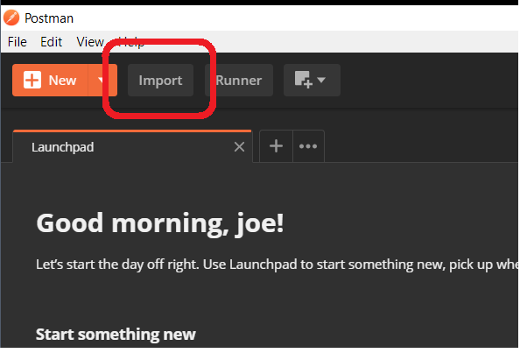

On the bottom left of Postman click ‘**Show Sidebar**’

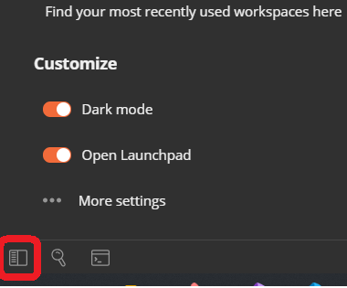

Select **‘Collections’** Tab

Click the **‘Expand’** arrow on the Collection and then **‘Run’** in the modal

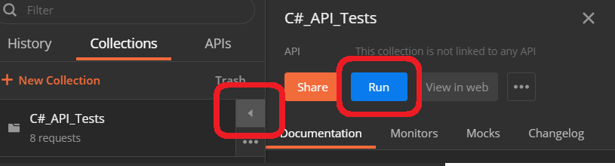

This will open the Collection Runner window

In the view click **‘Run [*test-name*]**’ to execute tests (also make sure the project’s server is running and on localhost!)

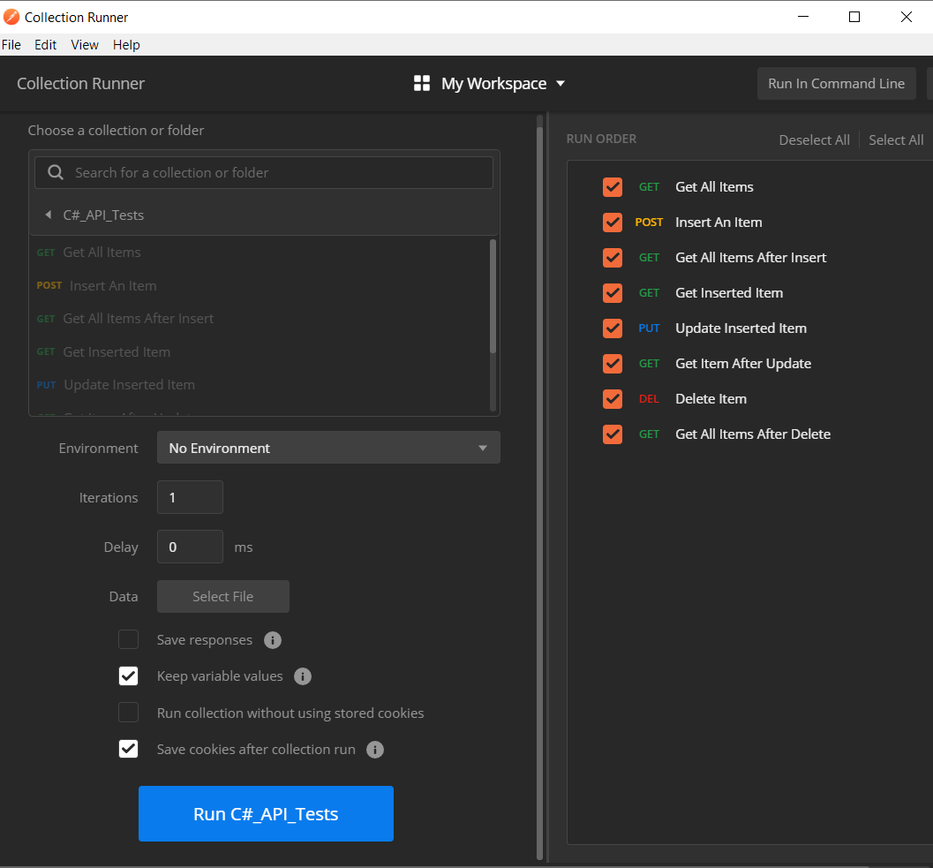

# Test Results View

# 

# 

# View Tests

To View the individual Tests in a Collection, expand a method and select the Test tab

